PROJECT DOCUMENTATION
1.INTRODUCTION
MicroGoals – Secure Goal Management Backend

- Flexibility and Adaptability: They can be easily adjusted to fit into a busy schedule, ensuring that progress continues even on low-energy or high-stress days.
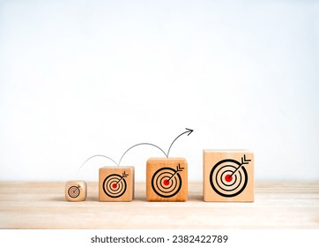
Team Id: SWTID-2026-5704
TeamLeader:
Mageshwari.V -24csmageshwari053@gmail.com
TeamMembers:
Madhumitha.B -24csmadhumitha051@gmail.com
Malathy.V -24csmalathy054@gmail.com
Manju.M -24csmanju055@gmail.com

2.Project Overview:
A Microgoal Project Overview focuses on breaking down large, complex, or long-term objectives into small, manageable, and actionable tasks that can typically be completed within a day or two, and certainly within a week. This approach, often referred to as "chunking," aims to boost motivation, foster consistent progress, and reduce the psychological overwhelm associated with massive projects.
- The System Includes:

1. Core Elements of a Microgoal
2. The Systematic Framework
3. Tracking and Feedback Mechanisms
4. Psychological & Cultural Components

- Ridiculously Small Size: Actions are so small they feel "silly" not to do, typically requiring 2–45 minutes or 1–7 days to complete.
- Macro-to-Micro Mapping: Breaking down a large, long-term goal (e.g., "write a book") into small, daily steps (e.g., "write 100 words").
- Visual Tracking: Utilizing tools like calendars, checklists, habit-tracker apps (e.g., Jira, Trello, Asana), or journals to monitor completion rates.
- Proactive Mindset: Shifting focus from perfection to progress, reducing procrastination, and overcoming fear of failure.

3.Project Instruction:
Microbial project instructions involve safely culturing bacteria, typically by creating agar plates, collecting samples, and incubating them for 4–5 days at room temperature. Common projects include testing antiseptics using zone of inhibition, creating bacteria-based agar art, or building a microbial fuel cell using soil mud and electrodes.
- Prepare Agar: Mix and boil nutrient agar, then pour into petri dishes and let them solidify.

- Sample Collection: Use a sterile swab to collect bacteria from surfaces (e.g., phone, doorknob) in a zigzag pattern.

- Inoculation: Gently rub the swab across the agar surface.

- Incubation: Seal plates with tape and store upside down in a dark, warm place for 4–5 days.

- Analysis: Count colonies, observe colors, and measure shapes.

4.Pre-requisites:
- Node.js
- Express.js
- MongoDB
- VSCode
- Thunder Client
- Basic javascript & reset APIs

Node.js & Express.js:



Node.js is a JavaScript runtime environment, while Express.js is a web application framework built on top of Node.js. They work together, with Node.js providing the server-side execution engine and Express.js offering a robust set of features to simplify web development, such as routing and middleware.

MongoDB:

Micro-goals for MongoDB are focused, actionable, and small-scale tasks designed to build proficiency in NoSQL database management. These goals range from understanding basic CRUD (Create, Read, Update, Delete) operations to implementing advanced features like aggregation pipelines and Atlas search.

Thunder Client:

Thunder Client is a lightweight, GUI-based API client extension for VS Code that enables fast REST and GraphQL testing directly within the IDE. It aims to improve developer workflow by allowing local, scriptless, and organized API testing, featuring request saving, environment variable management, and CI/CD integration.
Javascript&reset APIs:

Micro goals for a JavaScript REST API (Node.js/Express) include implementing stateless authentication (JWT), using plural nouns for resource naming (/users), returning proper HTTP status codes (200, 201, 404), validating input.
Project Architecture:
- Micro-housing projects (often referred to as micro-architecture or micro-projects) are characterized by highly efficient, compact designs—typically under 40 square meters—designed for dense urban areas to maximize space while providing essential living, working, and, or social functions.
Custom-Made, Multi-Functional Furniture: Custom furniture, such as shelving units and movable panels, often serves as the primary room configurator, acting as both storage and, at times, dividers or sleeping areas.
- Open Floor Plans: Open, flexible floor plans are commonly used to optimize space, allowing for different functions within a single room.
- Vertical Utilization: Retractable tables, lofted spaces, and vertical storage solutions are often incorporated to make the most of the limited, compact footprint.
- Space-Efficient Fixtures: Kitchens, bathrooms, and sanitary units are designed with standardized, compact measurements to fit in tight spaces.
- Strategic Material Use: The use of materials like plywood, wood, and concrete, as well as light-colored paint and mirrors, helps brighten, enlarge, and define the space.
Features:
- Micro-goals are tiny, manageable actions designed to break down overwhelming, long-term objectives into daily, actionable, and sustainable steps. They focus on consistency over intensity, helping to build momentum, reduce procrastination, and provide a constant sense of achievement.
Ridiculously Small/Simple: A micro-goal should be so small it feels almost silly to skip, taking only 5–10 minutes to complete (e.g., "do one push-up" rather than "work out for an hour").

- Actionable and Specific: They define a clear, immediate action, eliminating decision fatigue and making it obvious what needs to be done.

- Measurable: They have a clear metric of success, such as a specific number, time limit, or result (e.g., "write 50 words" instead of "write more").

- Achievable & Realistic: They are designed to be completed even on low-energy or busy days, fostering a sense of mastery without triggering the brain's fear response, according to behavioral psychology studies.
Time-Bound: They are short-term, often daily or weekly, ensuring rapid, consistent progress.
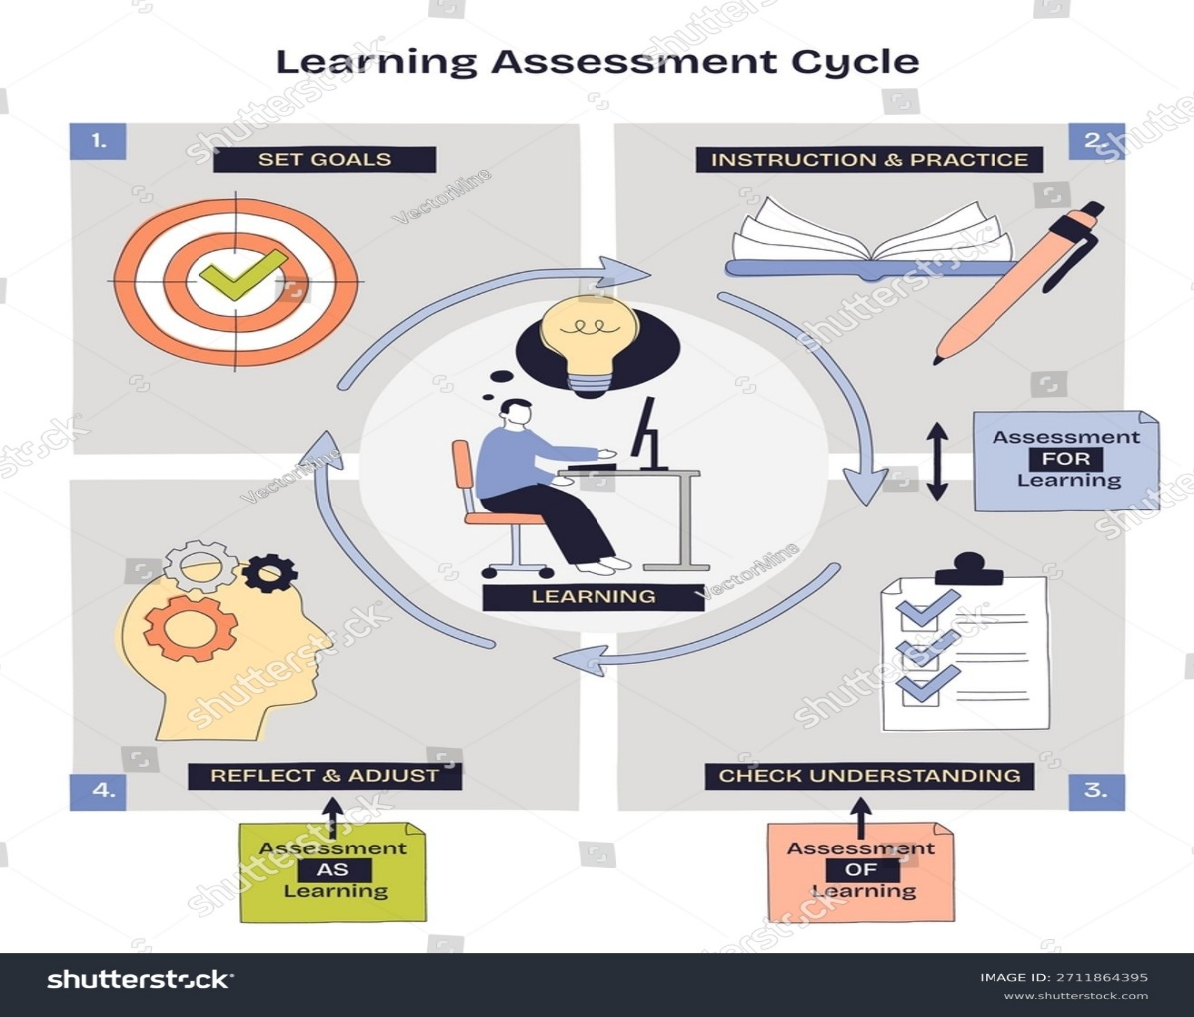

Flexibility and Adaptability: They can be easily adjusted to fit into a busy schedule, ensuring that progress continues even on low-energy or high-stress days.

Focus on Process over Outcome: They emphasize consistent, daily, or weekly action (e.g., "write for 5 minutes") rather than just the end result (e.g., "finish a book").

PROJECT SETUP AND CONFIGURATION:

🔹 Folder Structure
MicroGoals/
├── middleware/
│ ├── authMiddleware.js
│ └── errorMiddleware.js
├──Schema/
├──User.js
├──GoalSchema.js
├── models/
│ ├── userModel.js
│ └── goalModel.js
│
├── routes/
│ ├── authRoutes.js
│ └── goalRoutes.js
│
├── .env
├── Index.js
└── package.json

Project Setup:
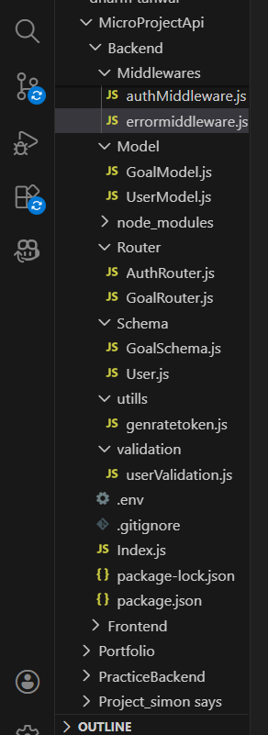

BACKEND DEVELOPMENT
OF THE PROJECT “MICROGOALS” …..
-TEAM LEADER:MAGESHWARI.V
-TEAM MEMBER:MADHUMITHA.B
-TEAM MEMBER:MALATHY.V
-TEAM MEMBER:MANJU.M

